Project Phase-II

Data Flow Diagram

|  |  |
| --- | --- |
| Date | 17 October 2022 |
| Team ID | PNT2022TMID11765 |
| Project Name | Real time River water quality  monitoring and control system |
| Maximum Marks | 4 Marks |

# Data Flow Diagram:

A Data Flow Diagram (DFD) is a traditional visual representation of the information flows within a system. A neat and clear DFD can depict the right amount of the system requirement graphically. It shows how data enters and leaves the system, what changes the information, and where data is stored.

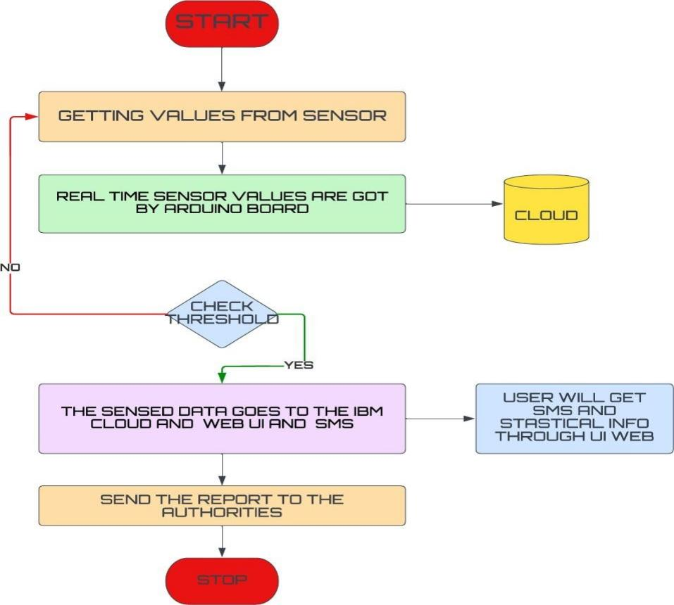

# User Stories

|  |  |  |  |  |  |  |
| --- | --- | --- | --- | --- | --- | --- |
| **User Type** | **Functional**  **Requirement (Epic)** | **User Story Number** | **User Story / Task** | **Acceptance criteria** | **Priority** | **Release** |
| Customer (Mobile user) | Registration | USN-1 | As a user, I can register for the application by entering email, password, and confirming my  password. | I can access my account/dashboard | High | Sprint-1 |
|  |  | USN-2 | As a user, I will receive a confirmation email once I have registered for the  application | I can receive e confirmation email &  click confirm | High | Sprint-2 |
|  |  | USN-3 | As a user, I can register for the application through Google | I can register & access  the dashboard with Google | High | Sprint-1 |
|  |  | USN-4 | As a user, I can register for the application through Gmail | I can register through the mail. | Medium | Sprint-2 |
|  | Login | USN-5 | As a user, I can log into the application by  entering email, password & captcha | I can receive login  credentials. | High | Sprint-1 |
|  | Interface | USN-6 | As a user, the interface should be user-friendly  manner | I can able to access  easily. | Medium | Sprint-1 |
| Customer (Web user) | dashboard | WUSN-1 | As a web user, I can access the specific info (ph value, temp, humidity, quality). | I can able to know the quality of the water. | High | Sprint-1 |
| Customer Care Executive  (input) | View manner | CCE-1 | As a customer care, I can view data in visual representation manner(graph) | I can easily understand by visuals. | High | Sprint-1 |
|  | Taste | CCE-2 | As a customer care , I can able to view the  quality(salty) of the water | I can easily know whether it  is salty or not | High | Sprint-1 |
|  | Color visibility | CCE-3 | As a customer care , I can able predict the water  color | I can easily know the  condition by color | High | Sprint-1 |
| Administrator | Risk tolerant | ADMIN-1 | An administrator who Is handling the system  should update and take care of the application. | Admin should monitor the  records properly. | High | Sprint-2 |